A Meta-Analysis of Expressive Writing on Quality of Life and Posttraumatic Growth

Jeffrey M. Pavlacic, Erin M. Buchanan, Ann D. Rost

Missouri State University

Abstract

Repressing negative thoughts or emotions can be detrimental to both physical and psychological health. Additionally, psychological dysfunction can create problematic health behaviors. Clinicians have considered a number ways for individuals suffering from psychological distress to effectively expressive these emotions. One therapeutic approach implemented by clinicians suggests that writing about these negative emotions can lead to reductions in psychological distress. Pennebaker (1997) suggests that writing about a traumatic event can reduce the psychological stress associated with that event. Expressive writing interventions have been adapted to interventions for a multitude of different variables and populations. Results from a met analysis suggest a small effect size for the effect of expressive writing on Posttraumatic Growth (PTG) and Quality of Life (QOL) variables for a variety of health-related illnesses and psychological disorders as a result of expressive writing. Additional research utilizing an expressive writing intervention under Pennebaker’s paradigm is necessary in order to discover the effectiveness of expressive writing on different health-related and psychological diagnoses.

*Keywords: expressive writing, posttraumatic growth, quality of life.*

A Meta-Analysis of Expressive Writing on Quality of Life and Posttraumatic Growth

**Problems Associated with Repressing Negative Emotions**

Inhibitory theory discusses how repressing negative thoughts or emotions can be detrimental to both physical and psychological health. Furthermore, the inhibitory theory postulates that individuals experiencing traumatic events are more likely to repress thought and feelings about a given traumatic experience. These repressive maneuvers have the capability to lead to social concerns and overall psychological dysfunction (Pennebaker & Beall, 1986; Pennebaker, 1989). Psychological dysfunction can have detrimental effects on an individual’s health, including unhealthy everyday life habits such as activity levels, overall quality of life, and inability to progress after a traumatic event. These unhealthy habits could lead to biological problems, especially immune system deficiencies and problems with neurotransmitters (Gangloff, Mayoral, & Vontrhon, 2016). Therefore, it is important to identify ways in which individuals can effectively expressive emotion, thereby improving both physical and psychological health.

**Expressive Writing**

Clinicians have considered and implemented many different ways for patients to successfully express their emotions. Verbalizing emotions has the capability to improve psychological well-being and improve psychological health, especially after experiencing a traumatic event (Smyth & Pennebaker, 2008). One type of therapeutic approach suggests that writing about negative emotional experiences leads to significant reduction in psychological distress (Pennebaker & Beall, 1986). Pennebaker (1997) has explored the use of expressive writing to elucidate the potential benefits of verbal expression of emotion. Pennebaker’s research suggests that writing about a traumatic event can help to decrease psychological distress related to the event. Since Pennebaker started utilizing expressive writing, many variations have been adapted to examine the effectiveness of different types of expressive writing for different symptoms and psychopathology (Manier & Olivares, 2005). Over 200 studies have been conducted utilizing expressive writing in some form. While many studies have been conducted regarding this therapeutic approach, the effectiveness of expressive writing remains unclear. Baikie & Wilhelm (2005) posit that expressive writing leads to improvements in both physical and psychological health across both clinical and non-clinical populations. Furthermore, writing about a previous traumatic experience leads to a short-term increase in arousal as well as a decrease in chronic health problems (Pennebaker & Beall, 1986). Usually, studies of this nature have participants write about a traumatic event for 3-5 sessions for a time period of 15-20 minutes. Thus, only studies fitting this criteria will be selected for this particular meta-analysis. Interestingly, at long-term follow up, studies have found evidence of health benefits from expressive writing, such as greater psychological well being, reduced depressive symptoms prior to examination, and fewer cases of post-traumatic intrustion and avoidance symptoms (Bikie & Wilhelm, 2005). However, a meta-analysis of the effectiveness of expressive writing has not yet been conducted on PTG and QOL outcome variables.

**Why is a Meta-Analysis Necessary?**

The literature shows contradictory results of the effectiveness of this type of intervention, which may be a factor as to why clinicians are hesitant to incorporate expressive writing into their treatment program. Henry, Schlegel, Talley, Molix, and Bettencourt (2010) found that expressive writing only benefited a rural population for those individuals surviving breast cancer. Lancaster, Klein, and Heifner (2015) found no significant evidence that expressive writing can be considered an effective approach. Expressive writing tasks fit well within the framework of different psychological interventions and can be adapted for treatment, which is why the literature includes many different studies looking at a multitude of variables. However, it is important to focus on individual variables in order to determine the effectiveness of expressive writing for specific diagnoses and psychopathology. As previously mentioned, some studies have found long-term benefits of expressive writing on psychological well-being (Park & Blumberg, 2002). However, other studies, such as the research done by Lancaster et al., (2015), have found no evidence supporting the utilization of expressive writing as an effective therapeutic approach. Thus, it is necessary to evaluate the effectiveness of expressive writing on specific outcome variables, such as PTG and QOL.

**Posttraumatic Stress Disorder and Posttraumatic Growth**

Posttraumatic Stress Disorder (PTSD) is a disorder involving reoccurring thoughts or experiences after a traumatic event or experience. The diagnosis is based on 20 symptoms structured into four different subsets. These subsets are as follows: re-experiencing, avoidance, negative alterations in cognition and mood, and arousal (Crespo & Mar Gomez, 2016). Research conducted on the effectiveness of expressive writing on PTSD symptoms has been less successful and shows outcomes that are not as effective as other studies (Sloan, Marx, & Greenberg, 2011). Posttraumatic growth (PTG) is a positive experience after a traumatic event (Yilmaz & Zara, 2016). Expressive writing has been shown to be an effective method for reducing psychological distress among those suffering from trauma (Sloan, Marx, Epstein, & Lexington, 2007). PTSD is concerning, specifically among Iraq and Afghanistan war veterans (Gentes et al., 2013). It is important to examine the effectiveness of an expressive writing intervention and look at how effective this approach is in promoting PTG and overall psychological health. Speculation suggests that those meeting the criteria for moderate PTSD benefit more from expressive writing interventions as opposed to those with greater PTSD symptoms (Di Blasio et al., 2015). If particular studies utilizing the expressive writing paradigm are shown to benefit the patient and create a more positive lifestyle, then it is necessary to determine the overall effectiveness of expressive writing on PTG.

**Quality of Life**

Quality of life (QOL) is another variable, related to PTSD and psychology health, that is worth examining with expressive writing interventions. Quality of life is described as a concept comprised of multiple domains. Objectively, QOL is a measure of the extent to which an individual’s needs are met. Subjectively, QOL measures an individual’s attitude towards their given situation (Costanza et al., 2006). Pennebaker and Graybeal (2001) suggested that expressive writing allows one to feel more connected with their surroundings. Furthermore, they explain that expressive writing allows people to see things in a different way and better understand themselves. By understanding the traumatic event, one is able to see things differently and perhaps look at the situation with a more positive mindset. The changes that occur after expressive writing may also allow one to find meaning in the traumatic event, thereby increasing the quality of life of that individual (Frankl, 1984). Higher QOL may be considered a type of PTG, which is why it would be interesting to examine the effectiveness of studies utilizing expressive writing to improve QOL and PTG in the same study and compare effectiveness.

**Purpose of Current Meta-Analysis**

The purpose of this meta-analysis is to examine studies utilizing expressive writing on quality of life and posttraumatic growth variables. As previously stated, research conducted on the effectiveness of expressive writing on PTSD symptoms has been shown to be less effective than XXX. Due to discrepancies of the results of the wide range of studies conducted, it is important to understand just how effective expressive writing is for promoting positive change after a traumatic event and improving overall quality of life. Thus, a meta-analysis will allow a collected look at the use of expressive writing in these situations. This particular meta-analysis examines studies of patients with different types of psychopathology and medical diagnoses on PTG and QOL outcomes. The main focus is to examine posttraumatic growth and quality of life and the effect sizes related to expressive writing interventions utilizing Pennebaker’s paradigm. Effect sizes will be compared across variables and diagnoses.

**Method**

For the studies used for this specific meta-analysis, a couple of different research designs were examined. Generally, groups were separated into an experimental and control group and then examined at different time points. For purposes of this meta-analysis, only participants assigned to the experimental condition were examined. Multiple data were collected after the expressive writing sessions at different time points in the experimental group in order to determine whether or not the effects are exhaustive. One study in particular utilized a regression style model. For the majority of the studies, however, different time points were examined to see if the effects changed. T-tests were utilized to compare the expressive writing group for each time point to determine whether or not they are statistically different. Effect sizes were converted to Cohen’s *d* using *R.* Effect sizes were then used to form a forrest plot, which is shown in *Figure 1*. For simplicity purposes, effect sizes and study information were also combined to form a table, which is shown in Table 1.

**Results**

*Figure 1* shows relevant Cohen’s *d* effect sizes. Average QOL effect size was XXX. Average PTG effect size was XXX. Average overall effect, *d* = .21, suggests a small overall effect size for expressive writing on both QOL and PTG. Table 1 specifies particular studies from which data were collected.

**-interpret effect size overall and by variable**

**-confidence intervals crossing or not crossing zero plus include confidence intervals in statistics**

**-concluding statement**

**Discussion**

**-discuss results compared to the norm view of expressive writing**

**-discuss limitation of not having enough studies to calculate effect sizes**

**-however be sure to mention the amount of articles we examined and what the existing results show for these two variables**

References

Crespo, M. & Mar Gomez, M. (2016). Diagnostic concordance of DSM-IV and DSM-5

Posttraumatic Stress Disorder (PTSD) in a clinical sample. *Psicothema, 28*(2). 161-166

Di Blasio, P., Camisasca, E., Caravita, S., Carla, S., Ionio, C., Milani, L, & Valtolina, G. (2015).

The effects of expressive writing on postpartum depression and posttraumatic stress

symptoms. *Psychological Reports, 117*(3). 856-882.

**Frankl**, V. E. (**1984**). Man's search for meaning (3rd ed.). New York: Simon & Schuster.

Lancaster, S. L., Klein, K. P., & Heifner, A. The validity of self-reported growth after expressive

writing. *Traumatology, 21*(4). 293-298.

Lepore, S. J., Revenson, T. A., Roberts, K. J., Pranikoff, J. R., & Davey, A. Randomised

controlled trial of expressive writing and quality of life in men and women treated for

colon or rectal cancer. *Psychology & Health, 30*(3). 284-300.

Lu, Q., Zheng, D., Young, L., Kagawa-Singer, M., & Loh A. A pilot study of expressive writing

among Chinese-speaking breast cancer survivors. *Health Psychology, 31*(5). 548-551.

Pennebaker, J.W. & Graybeal, A. (2001). Patterns of natural language use: disclosure,

personality, and social integration. *Current Directions in Psychological Science (Wiley-*

*Blackwell), 10*(3). 90-93.

Pennebaker, J. W. (1997). Writing about emotional experiences as a therapeutic process.

*Psychological Science, 8*(3). 162-166.

Pennebaker, J.W. & Beall, S. K. (1986). Confronting a traumatic event: toward an understanding

of inhibition and disease. *Journal of Abnormal Psychology, 95*(3). 274-281.

Sloan, D.M., Marx, B. P., & Greenberg, E. M. (2011). A test of written emotional disclosure as

an intervention for posttraumatic stress disorder. *Behaviour Research and Therapy,*

*49*(4). 299-304.

Sloan, D.M., Marx, B.P., Epstein, E.M. (2007). Does altering the instructional set affect written

disclosure outcome? *Behavior Therapy, 38*. 155-168.

Smyth, J.M. & Pennebaker, J. W. (2008). Exploring the boundary conditions of expressive

writing: in search of the right recipe. *British Journal of Health Psychology, 13*(1). 1-7.

Yilmaz, M. & Zara, A. (2016). Traumatic loss and posttraumatic growth: the effect of traumatic

loss related factors on posttraumatic growth. *Anatolian Journal of Psychiatry, 17*(1). 5-

11.

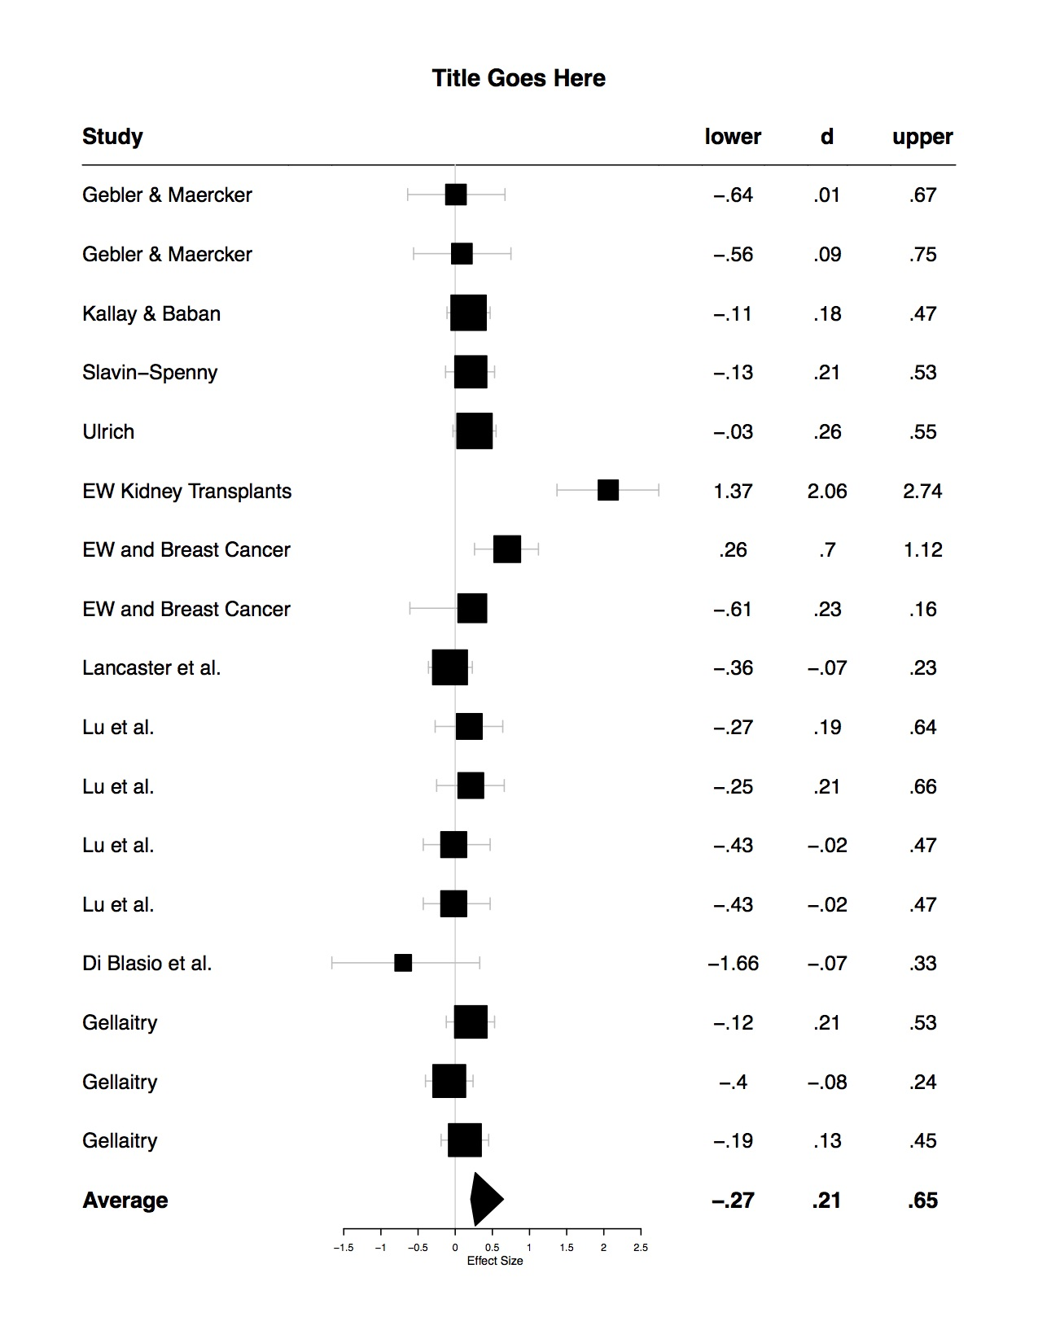

*Figure 1.* Cohen’s d average effect sizes for tests conducted utilizing expressive writing.

Table 1*.*

*Analysis type, relevant numbers, type of effect size, effect size, and 95% CI.*

|  |  |  |  |  |  |  |  |
| --- | --- | --- | --- | --- | --- | --- | --- |
| Article Author | Type of Analysis | Population | Effect size type | Effect Size | Lower Limit | Upper Limit | Variable (QOL or PTG) |
|  |  |  |  |  |  |  |  |
| Gebler & Maercker | MANOVA | Trauma-exposed individuals | d average | 0.01 | -0.64 | 0.67 | PTG |
| Gebler & Maercker | MANOVA | Trauma-exposed individuals | d average | 0.09 | -0.56 | 0.75 | PTG |
| Kallay & Baban | Paired samples t-tests at different time points | Cancer patients | d average | 0.18 | -0.11 | 0.47 | PTG |
| Slavin-Spenny | t-tests at different time points | Those exposed to stressful experiences | d average | 0.21 | -0.13 | 0.53 | PTG |
| Smith et al. | Hierarchial linear modeling | Individuals diagnosed with asthma | d average | Dr. B | Dr. B | Dr. B | PTG |
| Ulrich | MANOVA | Individuals exposed to traumatic event | d average | 0.26 | -0.03 | 0.55 | PTG |
| Possemato, Ouimette, & Geller | t-tests at different time points | Individuals who have undergone kidney transplant | d average | 2.06 | 1.37 | 2.74 | QOL |
| Craft, Davis, & Paulson | t-tests at different time points | Those diagnosed with breast cancer | d average | 0.70 | 0.26 | 1.12 | QOL |
| Craft, Davis, & Paulson | t-tests at different time points | Those diagnosed with breast cancer | d average | 0.23 | -0.61 | 0.16 | QOL |
| Lancaster, Klein, & Heifner | Mixed-model ANOVA (used time to time comparisons) | College students | d average | -0.07 | -0.36 | 0.23 | PTG |
| Lu, Zheng, Kagawa-Singer, & Loh | ANOVA (used time to time comparisons) | Look @ article | d average | 0.19 | -0.27 | 0.64 | QOL |
| Lu, Zheng, Kagawa-Singer, & Loh | ANOVA (used time to time comparisons) | Look @ article | d average | 0.21 | -0.25 | 0.66 | PTG |
| Lu, Zheng, Kagawa-Singer, & Loh | ANOVA (used time to time comparisons) | Look @ article | d average | -0.02 | -0.43 | 0.47 | QOL |
| Lu, Zheng, Kagawa-Singer, & Loh  Di Blasio et al.  Gellaitry | ANOVA (used time to time comparisons)  ANCOVAS & Regression models (time by time comparison)  Repeated measures ANOVAS (used time by time comparison) | Look @ article  Women after childbirth  Breast cancer patients | d average  d average  d average | -0.02  -0.70  0.21 | -0.43  -1.66  -0.12 | 0.47  0.33  0.53 | PTG  Posttraumatic Stress  QOL |
| Gellaitry  Gellaitry | Repeated measures ANOVAS (used time by time comparison)  Repeated measures ANOVAS (used time by time comparison) | Breast cancer patients  Breast cancer patients | d average  d average | -0.08  -0.19 | -0.40  0.45 | 0.24 |  |